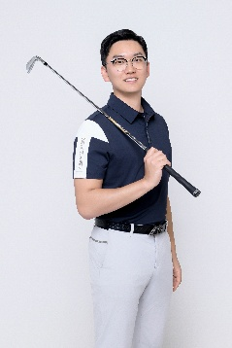

Minho Hong

Email: minho9707@naver.com / minho9707@gmail.com

Qualifications
- PGA Professional (GB&I)
- Level 1 Coaching in Golf (ASQ) Associated Sports Qualification
- Level 2 Coaching in Golf (ASQ) Associated Sports Qualification
- United States Golf Teacher’s Federation member
- Titleist Performance Institute(TPI) level 1
- Titleist Performance Institute level(TPI) 2 Golf
- True Temper fitting Certified Fitter
- Golf Pride Grip Certified Fitter
- IB bilingual Diploma (English-Korean)
- German B1

Education

University of Birmingham
- Major: Applied Golf Management Studies (AGMS), 2019

International School of Frankfurt
- International Baccalaureate Diploma
- Bilingual Diploma (English-Korean)

Language

Korean (Fluent)

English (Fluent)

German (B1)

Career

Lesson professional (2025)
- Dubai Dream Golf Town (Dubai, UAE)

Lesson professional (2021-2024)
- Solid Golf Studio (Korea)
- TPZ Plaza

Assistant Professional(2017)
- Hof Hausen vor der Sonne GC (Germany)

Hof Hausen vor der Sonne GC PLayer(2013-2016)
- Kramski Liga player
- European Sports Conference winner 2014-2015

