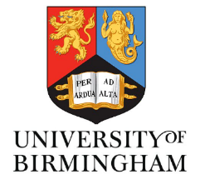
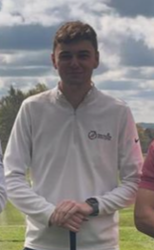
Jonathan Goodswen
12 Durham Park
Kilfennan, Londonderry
Northern Ireland
BT47 5YD
United Kingdom
+44 7366 888104
Jonathangoodswen16@gmail.com

PROFILE

Hardworking and enthusiastic graduate with a BSc in Applied Golf Management Studies from the University of Birmingham. Following my graduation, I spent seven months working at Sailfish Point, a private country club in Florida, gaining valuable international experience within the golf industry. Upon returning home I resumed my role at Total Golf and more recently working part time at my local club Faughan Valley. I am passionate about golf both as a career and a sporting activity, with a strong desire to progress through the PGA training pathway while developing the skills and attributes necessary to thrive within the industry.

EDUCATION AND QUALIFICATIONS

University of Birmingham September 2021 – May 2024
- BSc: Applied Golf Management Studies (Undergraduate 2:1)

Modules including:
- Applied sports science and golf coaching
- Equipment technology and applied custom fitting
- Golf operations management
- Leading and managing people in sport
- Managing golf events
- Sport, Exercise and Health psychology

Foyle College September 2014 – June 2021
- A level: Business Studies (B), Geography (B), Geology (B)
- GCSE: Further Math (B), Math (A*)
- English Language (C*), English Literature (C*)
- Business Studies (A), Chemistry (C*), French (C*) Geography (B)
- Physics (B) Religious Studies (short course) (C*)

Further Training
- ASQ level 1 award in golf coaching
- Safeguarding and child protection course
- Basic first aid training

EMPLOYMENT
Total Golf - Sales Assistant June 2022 – October 2025

- Worked during university holidays and since returning from Florida on a part-time basis, gaining consistent experience in customer service and retail operations.
- Provided expert customer service, advising golfers on equipment and apparel to match their needs.
- Assisted with junior coaching sessions, supporting the coaches with set-up, organisation and player engagement
- Developed product knowledge across leading golf brands and equipment technologies.
- Built strong communication skills through regular interaction with customers, juniors and other members.

Sailfish Point Country Club – Golf Operations October 2024 – May 2025

- Gained international experience at an exclusive private members country club, delivering a premium standard of service.
- Strengthened teamwork, adaptability, and customer service skills in a fast-paced, outdoor environment.
- Supported daily golf operations including bag drop, cart management, range setup, and practice facility maintenance.
- Worked closely with professionals and senior staff, gaining insight into private club standards, member relations, and tournament preparation.
- Played an active role in ensuring members and guests experienced a welcoming and professional environment.

ACHIEVEMENTS
Charity Golf Day

- Successfully co-organised a charity golf day as part of a "Managing Golf Events" module, raising £6000 for the Els for Autism charity, the highest amount ever raised in that module.

