Dominic O'Brien
Aspiring PGA Golf Instructor | NCAA Division II Golfer | Business Development Professional
📍Manchester, England | 📞 +44 7733468056| 📧 dlobrien89@outlook.com| 🌐 https://www.linkedin.com/in/dominic-obrien59/
Professional Summary
Former NCAA Division II golfer and Srixon/Cleveland Golf All-America Scholar with a strong foundation in competitive golf and business development. With years of high-level athletic experience and professional skills in client strategy and team leadership, I am pursuing a career as a PGA golf instructor. I will be combining my elite sport insight, a passion for coaching and a deep understanding to global corporate sales and a track record of driving success. I have previous experience working in Golf retail and professional shops meaning an easy transition into the Professional Golf world.
Golfing Achievements
- • NCAA Division II Collegiate Golfer, Barton College (2016–2020)
- • Srixon/Cleveland Golf All-America Scholar (2019–20)
- • All-Conference Carolinas Selection (2019–20)
- • Stroke average under 74.0 (2019-20)
- • Competitor in over 15 NCAA Intercollegiate Tournaments with 2 top 10’s and a top 5 (Bearcat intercollegiate 2019, Barton Intercollegiate 2019, Griffin Blake Memorial 2019,)
- • Club Champion – [Warrington Golf Club, 2022]
- • Club Matchplay Champion – [Warrington Golf Club, 2022]
Business & Management Experience
Business Development Support Manager – [DHL Supply Chain], Rugby, UK (Jan 2024–Present)
- Helped deliver over Increased revenue and AGP by 30% through new acquisition and prospecting/targeting strategies
- Prospected and developed relationships with global clients in Healthcare to provide large scale national and regional supply chain solutions e.g bioMerieux and Roche Pharmaceuticals
- Managed a £29M+ pipeline and supported high-level £5m AGP deals
- Led CRM management and support of NHS Hospital logistics contracts
Business Engagement Advisor– [St Helens Chamber], Manchester, UK (May 2023–Dec 2023)
- Managed client portfolio with a 95% retention rate
- Delivered data-driven sales campaigns and supported new membership growth including an Indoor Golf facility new startup [Virtuoso Golf, Haydock.]
Core Skills
Golf & Coaching:
- - Swing analysis
- - Short game training
- - Mental coaching
- - Tournament preparation
- - Proficient Trackman & Custom Fitting knowledge
- - Proficient Skillset in club repairs, re-gripping, re-shafting.
Business & Leadership:
- - Strategic sales execution
- - Cross-functional leadership
- - CRM & data insights
Education & Certifications
• B.A. (Hons) Business Administration – Barton College, 2020
• B.A. (Hons) Sports Management– Barton College, 2020
• FdSc - BSc (Hons) Professional Golf Studies – Planned (once employment confirmed)
• DBS Certified

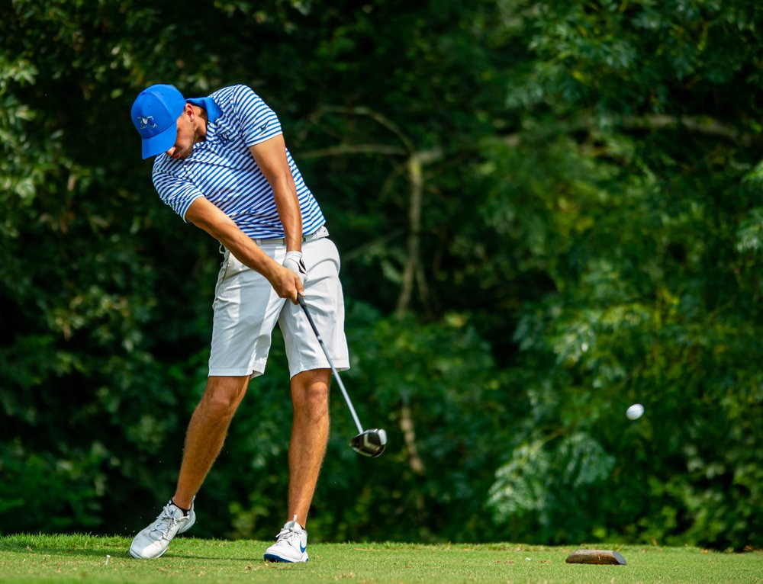
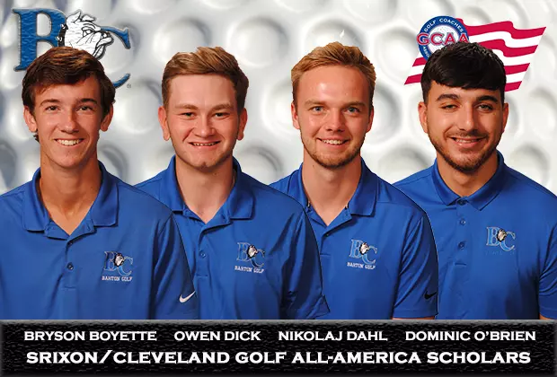
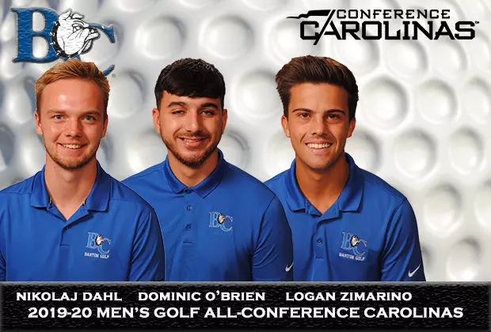
Photos & Visuals

