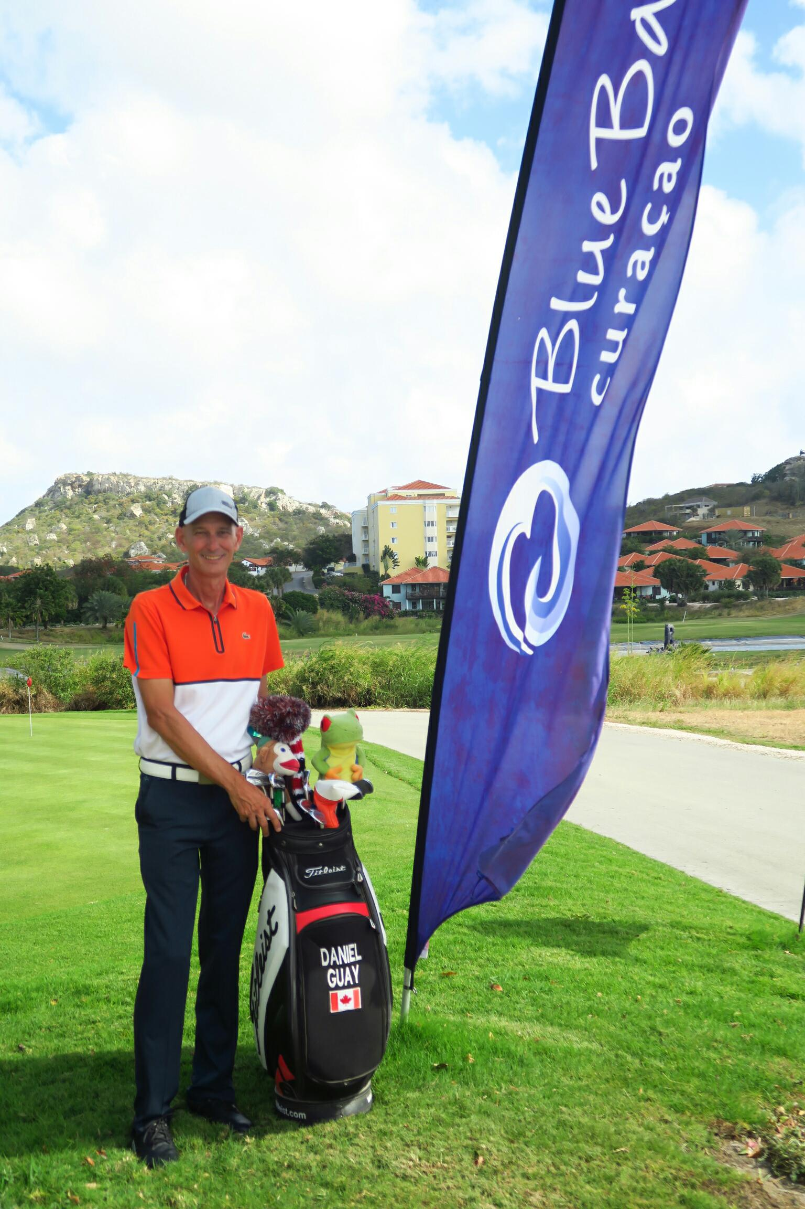 |  |  | dANIEL Guay  OBJECTIVE: to deliver an enjoyable golfing experience to all members, guests, and newcomers  LANGUAGES  Fluent in English, French, and conversational Spanish  PROFFESSIONAL EXPERIENCE  Golf professional  Astute, tenacious, and diligent golf professional with extensive training, comprehensive work experience and verifiable success in all aspects of golf operations. Equipped with hand on leadership, business management, and customer service expertise. Talented player and member of the Professional Association of America (IPGA) well-versed in coaching and instructing diverse individuals at all levels of the game.  EDUCATION and CERTIFICATIONS  Golf Teaching Professional Certification  International PGA (Port St. Lucie, Florida)  License # 6656  Smart Serve certification  Ontario  Club fitting and repair  Certification from Titleist, Ping, Cobra and Callaway Canada. Master clubs fitter certification from Golftown Canada.  First degree Business Management program Quebec, Canada  Diploma formación inmobiliaria de ejecutivos de ventas, Dominicana República.  SKILLS•  Assisting financial processes of the club including budgeting, expense management and capital spending.  •Implements an approved budget, forecast and staffing plan for the golf department  •Provide the membership with a consistently first-rate food and beverage service.  •Developing creative and new merchandising strategies, Purchasing clothing, golf accessories  providing support and guidance to the Board of Directors on developing a long-term plan and the capital requirements to support it.  •Implementing a broad, multi-faceted communications plan to reach all member categories.  •Live locally and serve as an ambassador for the club in the broader community.  •Hiring and oversee employees Training and sales  • Manages public and member golf tournaments from start to finish.  •Works with all departments to plan and oversee all events and tournaments.  •Manages the daily opening and closing of golf operations  •Manages tee sheet and performs starter of marshal duties  •Manages the handicap system for members  •Communication and coordination: with media, members, and guests for all events at the clubs
Cell: 679-714-5269
dangolf1@hotmail.com

CAREER OVERVIEW

Spur Valley golf Resort, B.C.
2024 Dorchester golf course, Canada
2022 bluebay resort, Curacao From 2008 to 2021 (summer season)
Master club fitting: Golf town Canada
Sandpoint G.C. Arnprior, Ontario.
Madawaska G.C, Arnprior, Ontario.

Club de golf heritage, Qc.
2008 to 2021(winter)

Punta Blanca Golf Course, Dominican Republic

Catalonia Bavaro Beach Casino and Golf Resort, Dominican Republic

Club Med Punta Cana Resort, Dominican Republic

Give golf lessons and play golf with guests.

Do briefing at the hotel to sell golf.
Work in real estate for sale & rental

2001 to 2008 (year Long)

Lake Worth Executive Golf, Palm Beach, Florida
Played competitive golf on the pro tour

