Alfie Simpson
Professional Golf Player
6 Alexander Avenue, Angmering, West Sussex, UK, BN16 4PQ
M: +44 7769 113283 | Email: alfiesimpson.golf@gmail.com
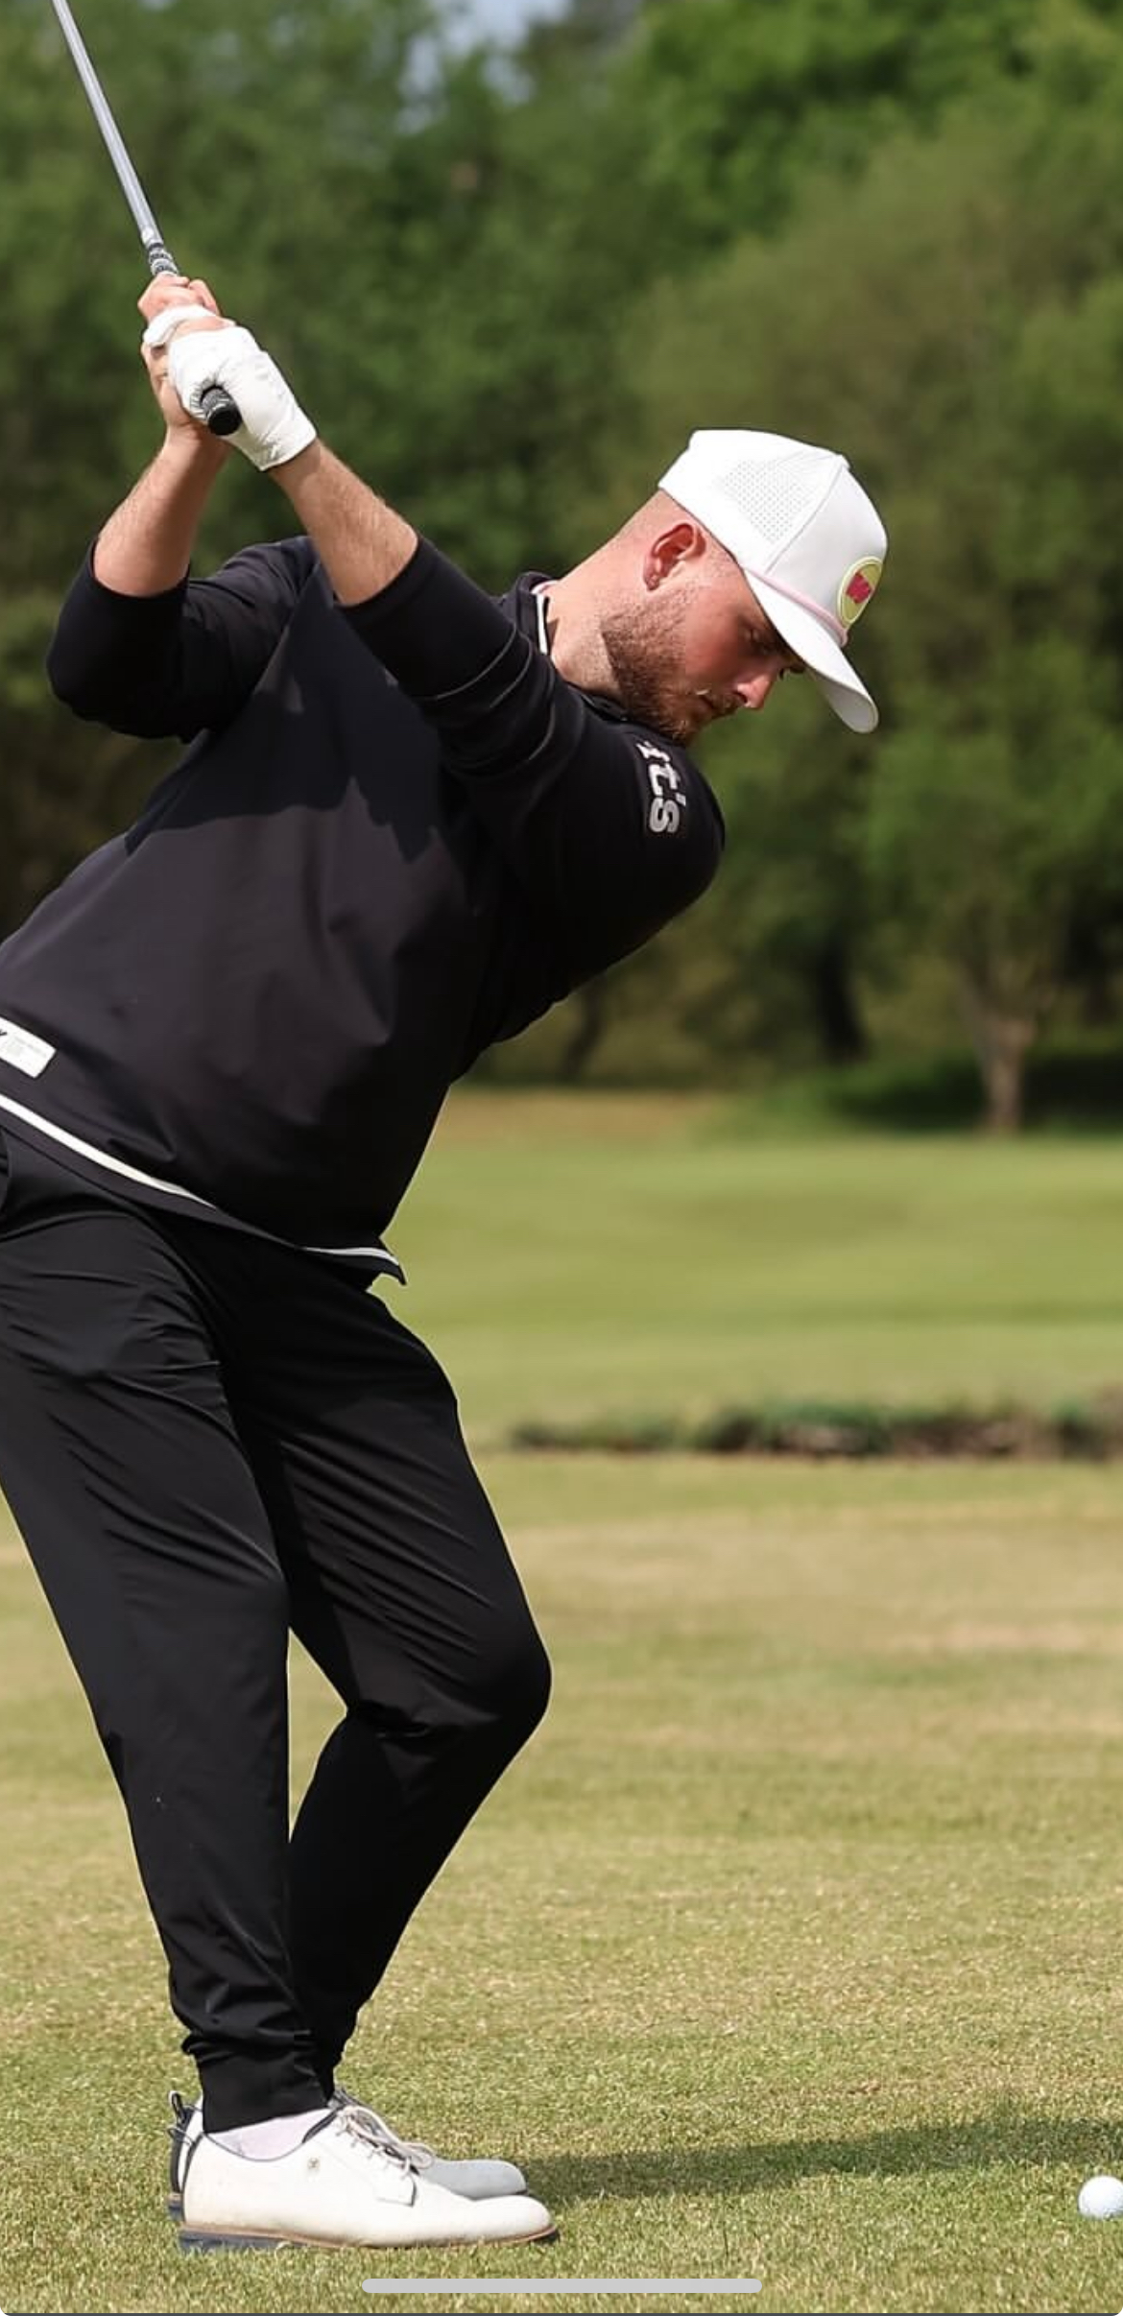

Personal Profile
A passionate, hard-working young golf professional with a lifelong dedication to the game and a proven record of junior and professional success. From representing Wales and Sussex at national and County level to competing on professional tours in the UK and Europe, I bring a strong competitive mindset, discipline, and professionalism both on and off the course.
I developed a +2 handicap by age 17 and turned professional shortly after. I’m now looking to grow my experience and work towards my PGA qualification, while being a positive part of your club.
I’m approachable, reliable, and always willing to work hard. I enjoy helping members, supporting coaching teams, and representing the club when needed. My long-term goal is to coach golfers of all ages and abilities.
I’m also keen to learn more about the club shop and the retail side of the business, and I’m fully prepared to help with whatever else is needed to keep the club running well.

Key Golfing Achievements
- Started playing golf at age 7 and quickly developed into a leading junior competitor.
- Winner – Nett Prize, World Series of Golf (Portugal, Under 12s).
- Runner-up – U14’s in Canada and Wales U14 Tournament.
- Represented Sussex at U12, U14, U16, and U18 level, winning the National Counties Championship at U16.
- Represented Wales at U16 level and competed in multiple Independent School Championships.
- Winner – Goodwood Junior Championship and Runner-up – Sussex U18 Championship.
- Graduated from The Golf College (BTec in Sport), achieving a +2 handicap at age 17 before turning professional.
- Professional playing experience includes the Jamega Tour, Marbella Tour, and Clutch Tier 2 & Tier 1 Tours.
- Top finishes: 4th in a Clutch Tier 2 event, Top 20 in a Tier 1 event.
- Winner – Sussex PGA Tournament (Bognor) and 3rd in Sussex PGA at Goodwood (2024).
- Coaching & mentoring experience: Supported a two-week Espire Golf junior training camp at Seaford College.

Education
The Golf College, UK – BTec Diploma in Sport
• Achieved Level 4 in both Maths and English.
• Focused on golf performance, sports science, psychology, and player development.

Professional Skills
- Strong technical and playing knowledge across all aspects of the game
- Excellent communication and teamwork.
- Reliable and adaptable.
- Full UK Driving License and flexible with travel and working hours

Career Objective
To secure a part-time or full-time position within a respected golf club in Surrey, where I can contribute positively to the professional team, develop my coaching and playing skills, and prepare for my PGA qualification.

References
Available upon request.

Dear Sir,
I am writing to express my interest in becoming your club's Junior PGA Assistant. My goal is to begin the PGA qualification pathway, and I am eager to build further experience in a high-quality golf club such as yours.
Golf has been central to my life from an early age. I represented Sussex County, UK at U14, U16, and U18 level, as well as Wales at U16. Since turning professional, I have competed on the Jamega Tour, Marbella Tour, and, most recently, qualified for the Clutch Tier 1 Tour in November 2024. Highlights include finishing 3rd in the Sussex PGA event at Goodwood and winning a PGA event at Bognor. These experiences have deepened my understanding of the game, professionalism, and the standards required to perform at a high level.
Alongside competing, I am passionate about helping others develop their skills and enjoyment of golf. I believe that working within a respected club environment would allow me to contribute positively to your members, support the coaching team, and further my development as a future PGA professional.
I hold a full UK driving license, am flexible with travel and working hours, and have completed my BTEC Diploma in Sport at The Golf College, achieving Level 4 in both Math’s and English. I am reliable, motivated, and fully committed to representing your club to the highest standard.
I would greatly appreciate the opportunity to discuss how I could support your team.
I look forward to hearing from you.
Kind regards,
Alfie Simpson
Mobile: +44 7769 113283 | Email: alfiesimpson.golf@gmail.com

